13.83: a) 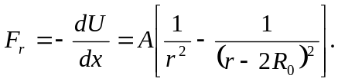
b) Setting the term in square brackets equal to zero, and ignoring solutions with
c) The above expression for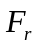may be written as
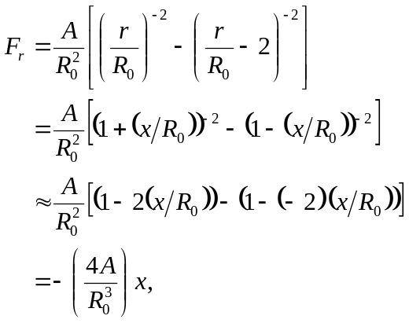

corresponding to a force constant of 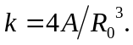 d) The frequency of small oscillations would be 